
PerkinElmer
Corporate Site – Phase 1
Build Document
Project 1001005
22nd February 2013

Chris Eccles
16th June 2014
BB Ref: 101567

Change History
Version | Date | Change | Author
0.1 | 24/06/2014 | Initial Version | Chris Eccles
0.2 | 03/07/2014 | Internal Review | Adam Seabridge
0.3 | 04/07/2014 | Implementing review feedback | Chris Eccles
1.0 | 06/07/2014 | Changes after call | Chris Eccles
1.1 | 11/07/2014 | Changes after client feedback | Chris Eccles
1.2 | 15/07/2014 | Updates to include info on WCF Service and review changes | Adam Seabridge

Distribution List and Approval
Issued for Information (I), Review (R), Sign-Off (S)
Name | Organisation | Project Role | I/R/S
Subash Narasimhan | PerkinElmer | IT Technical Team Leader | S
Gauri Chary | PerkinElmer | Project Manager | S
Srikanth Baheti | PerkinElmer | Software Engineer | R
Adam Seabridge | Building Blocks | Technical Manager | R
Melissa Hermitt | Building Blocks | Project Manager | I

Related Documents
Document Name | Version
Corporate Site_Components_Functional Spec | 1
Social Media Integration | 1
Interactive Contact-Map Requirements | 1

Contents
1. Introduction 8
2. Technical Solution Architecture 9
2.1. Functional Overview 9
2.2. Infrastructure Architecture 10
2.2.1. Development 10
2.2.2. Test 10
2.2.3. Author 10
2.2.4. Production 11
2.3. Logical Architecture 11
2.4. Publishing Method 11
2.5. Deployment 11
2.6. Logging / Error Handling 12
3. Technologies 13
3.1. Dynamic Delivery for Tridion 1.31 (DD4T) 13
3.2. ASP.NET MVC 5.1 13
3.3. SDL Tridion 2011 SP1 13
3.3.1. Dynamic Linking 13
3.3.2. Dynamic Content Delivery 14
3.4. SQL Server 14
3.5. jQuery 14
3.6. jQuery AJAX 14
3.7. Git 15
3.8. TeamCity 15
3.9. Unity 15
3.10. NUnit 15
4. Tridion Implementation 16
4.1. BluePrint Model 16
4.2. Templating Model 17
4.3. Schemas 18
4.3.1. Content Schemas 18
4.3.2. Metadata Schemas 20
4.4. Taxonomy 21
4.5. Page Templates 22
4.5.1. Full Width 22
4.5.2. 2 Column Left 22
4.5.3. 2 Column Right 22
4.6. System Page Templates 23
4.7. Component Templates 24
4.7.1. General Content 24
4.7.2. Text with zoom image 25
4.7.3. Image with caption 26
4.7.4. Text with quote 27
4.7.5. Secondary Navigation 27
4.7.6. Intro Title 28
4.7.7. News Title 29
4.7.8. Banner 29
4.7.9. Carousel 31
4.7.10. Hero 32
4.7.11. Promo 33
4.7.12. Product Verticals List 34
4.7.13. Leadership List 35
4.7.14. Leadership Detail 36
4.7.15. Homepage Feature 38
4.7.16. Feature 39
4.7.17. Full Feature 40
4.7.18. Large Feature 42
4.7.19. Sitemaps 43
4.7.20. Newsletter signup 44
4.7.21. Social News 44
4.7.22. Side Content 45
4.7.23. Side Image 46
4.7.24. Article links 47
4.7.25. Resource List 48
4.7.26. Side Navigation 49
4.7.27. Share/Favourite 50
4.7.28. Summary List 51
4.7.29. Logos & Images List 52
4.7.30. Videos & Podcasts 53
4.8. Dynamic Templates 54
4.8.1. Feedmagnet widget 54
4.8.2. Dynamic News Navigation 55
4.8.3. Featured Dynamic News 56
4.8.4. Dynamic News List 56
4.8.5. Related News Dynamic List 57
4.9. System Component Templates 58
4.9.1. DD4T Templates 58
5. ASP .Net Controls 59
5.1. Global Page Elements 59
5.1.1. Header 59
5.1.2. Top Navigation 59
5.1.3. Language Switcher 61
5.1.4. Search 62
5.1.5. Footer 62
6. .NET Code 63
6.1. .Net Classes 63
6.1.1. News Service 63
6.2. Solution Architecture 64
6.2.1. Website Code Architecture 64
6.2.2. C# Template Building Blocks Code 65
6.3. PKI Tridion WCF Service 65
6.4. Additional Libraries 66
7. Integrations and Services 67
7.1. Third Party Integrations 67
7.1.1. Feedmagnet 67
7.1.2. Facebook 67
7.1.3. Twitter 67
7.1.4. Linked In 67
8. Tracking 68
8.1. Event Tracking 68
8.2. Adobe Analytics script 68
8.3. Rich Snippets 68
8.3.1. Person 69
8.3.2. Video 69
9. Client Side Technologies 70
9.1. HTML5 70
9.2. jQuery 70
9.3. jQuery Unobtrusive Validation 70
9.4. HandleBars 70
9.5. Grunt.js 71
9.6. Assemble 71
9.7. Fonts 71
10. Technical Assumptions 72
11. Development Principles 75
11.1. Error handling 75
11.2. Caching 76
11.3. Naming Conventions 76
11.4. Testing 76
12. Deployment and Rollback 77
12.1. Deployment 77
12.2. Rollback 78
13. Appendix A - Code Casing Conventions 79
13.1. C# 79

Introduction
This document serves as the Technical solution design for the PerkinElmer Corporate site project. The new website content managed and delivered from an SDL Tridion 2011 SP1 platform. The following sections document in detail the architecture and technical design of the solution, based on the existing requirements documentation.
This is the technical build document for the phase 1 of the project. This only details the implementation of the phase 1 requirements. A separate phase 2 build document will be produced for phase 2.

Technical Solution Architecture
This section of the document provides high level overview of the solution architecture and implementation.

Functional Overview
The solution will use Tridion as the CMS to enable content managers to manage the content on the site.
The solution will be implemented using DD4T which allows the content and design of the page to be disconnected. This allows the content to be managed in the CMS and the design and templating to be handled through application deployments.
The Tridion content broker database will be contacted through a new DD4T WCF service provided by PerkinElmer. This will be called through a new provider for DD4T. The new WCF service will expose the methods for a DD4T content provider. This will also be exposing additional methods so that the taxonomy can be queried through the service as well.
There will be a number of static and dynamic templates created to enable the creation of the corporate site based on the designs and wireframes provided to Building Blocks by Zero Degrees.
The majority of the site will comprise of flexible static content that is content managed on each page. There will also be dynamic sections of the site that render out components based on filters and the latest content. For phase one only the dynamic news components will be created the later phases will deal with the products, contacts and events.
The site will also display responsively on a mobile and tablet devices using Responsive Design techniques.
Please see the Corporate Site_Components_Functional Spec for a breakdown of the components and their functionality.

Infrastructure Architecture

Development
The development server will be hosted at Building Blocks and will consist of a single server. Developers will be able to run the web application locally due to DD4T.
The Tridion instance will be called perkindev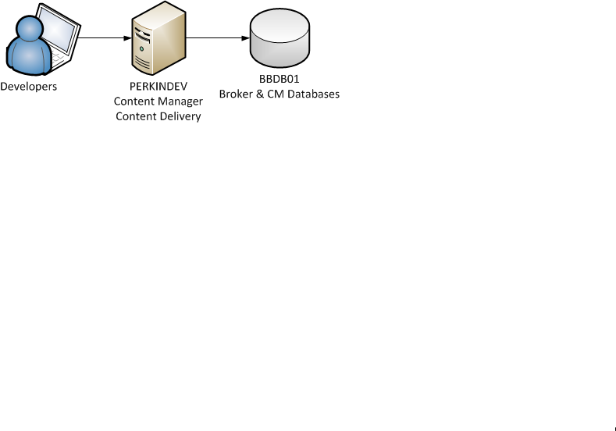

Test
The Test server is hosted at Building Blocks and will consist of a single server containing both Content Manager and Content Delivery.
The Tridion instance will be called perkintest
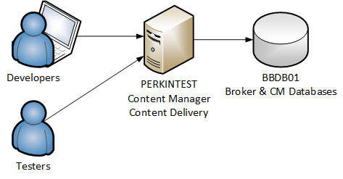

Author
[To be provided by PKI] [TBC]

Production
[To be provided by PKI] [TBC]

Logical Architecture
The logical architecture of the solution is shown below and details the interaction between all of the main aspects of the PerkinElmer Corporate site solution.
The DD4T framework will communicate to the broker content delivery API through a WCF service.
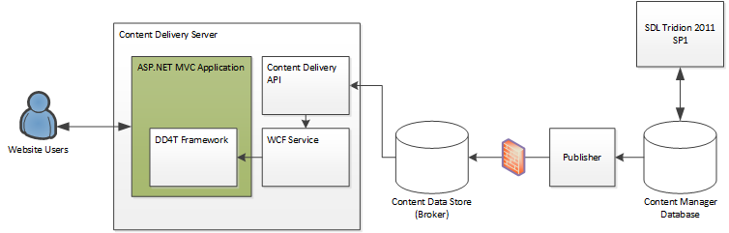

Publishing Method
On the Production environment the publishing of Tridion held content will continue to be done through FTP. We will use Windows Services running on the Deployment server handling the unpacking, storing and reporting of the transport packages.

Deployment
Major deployments between the four environments (Development, Test, QA and Production) will be done using one of two mechanisms:
- Using Content Porter for the deployment of items held within Tridion.
- The copying of individual files/folders held outside of Tridion (e.g. 3rd party DLL files, etc.). Within Building Blocks internal environments, Team City will be used to deploy these items. We will also use Team City to deploy to some PKI environments where possible.
- Use of WebDav to deploy Template Designs and User Controls

Logging / Error Handling
Logging and error handling throughout the application will follow the Building Blocks guidelines as outlined in the Development Principles section of this document.

Technologies
The following technologies form the basis on which the new PerkinElmer Corporate site will be built. Please see the websites of the individual technologies for further details.

Dynamic Delivery for Tridion 1.31 (DD4T)
Website: https://code.google.com/p/dynamic-delivery-4-tridion/
Dynamic Delivery for Tridion is an open source project which allows ASP.NET MVC to be used as the delivery mechanism for a Tridion website.
Content is published as XML into the Content Data Store database and retrieved by a set of providers.

ASP.NET MVC 5.1
Website: http://www.asp.net/mvc/mvc5
ASP.NET MVC 5.1 is a Model View Controller Framework on the ASP.NET engine.
It enables separation of concerns and provides a smooth web friendly development experience.

SDL Tridion 2011 SP1
Website: http://www.sdl.com/en/wcm/products/sdltridion/
SDL Tridion 2011 SP1 will be used as the platform for this project.
We will detail here the Tridion modules and features that will be utilised by the Tridion Implementation project.

Dynamic Linking
Dynamic Linking is a standard piece of SDL Tridion functionality that prevents dead links from appearing on web pages when linked content is removed (unpublished). Tridion manages metadata about all published content on the web servers, and dynamically creates content links when a page is requested. If content is no longer available (i.e., it has been unpublished) the link is either not rendered at all, or rendered as text only.
Link information will be stored in the Content Broker database.

Dynamic Content Delivery
Using Dynamic Content Delivery, individual pieces of content are stored separately in the Content Data Store on the Presentation Server. They are then retrieved dynamically from the Content Data Store by the Content Broker at request time, based on script code on the Web page.
Component custom metadata will be used to create filters to provide a way to dynamically select a subset of Component Presentations by querying Component metadata.

SQL Server
Website: http://www.microsoft.com/sqlserver
Microsoft SQL Server 2008 R2 will be used as the database technology to support the project. Further details about the databases being used can be found in the Databases section below.

jQuery
Website: http://jquery.com/
jQuery is the industry standard JavaScript library. It is cross-browser compatible and is easily extensible through its plug-in framework.

jQuery AJAX
Website: http://api.jquery.com/category/ajax/
AJAX requests will be made through a WCF web service using the jQuery AJAX plug-in.

Git
Website: http://git-scm.com/
Git is a free and open source distributed version control system designed to handle everything from small to very large projects with speed and efficiency.

TeamCity
Website: http://www.jetbrains.com/teamcity/
TeamCity is a continuous integration server that Building Blocks will use collate, build, test and deploy website code (to the Building blocks environments) during the website development. It works closely with code managed in Git to ensure the quality of builds and releases.

Unity
Website: http://unity.codeplex.com
Unity is an Inversion of Control library and Dependency Injection framework which integrates well with the Entity Framework 6 ORM framework. This library will be used for all IOC required for the Corporate project

NUnit
Website: http://www.nuget.org/packages/nunit
NUnit is a well-regarded and well-documented unit testing framework for .NET.

Tridion Implementation

BluePrint Model
The new PerkinElmer Corporate site Tridion BluePrint is shown in the diagram below.
The Blueprint will use the existing blueprint for the Microsites up to the 02 Layer. The new corporate site will share the schemas and Functional TBBs with the Microsites but the templates and content will be specific.
This is shown in the Blueprint model. :

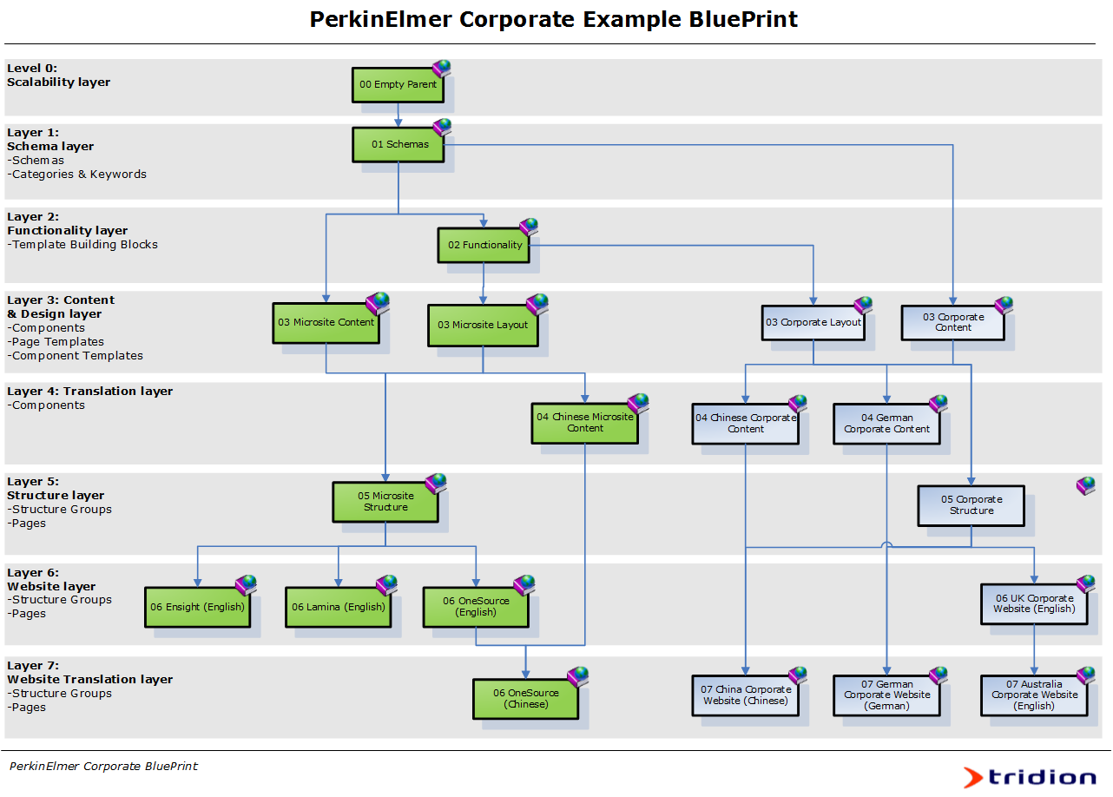
The green publications already exist in the microsites blueprint tree.
There will be translated content publications created for each of the different languages that are to be supported. Only two examples are shown the diagram. For launch the plan is to have the following translation publications:
- Chinese
- Polish
- German
- Austrian
- French
- Italian
- Spanish
These translation publications will then feed in to the language specific sites.
All publications will inherit a content publication and the 05 Corporate Structure publication. The structure publication is where the pages and structure groups are created. This will act as the master site where all other sites are based from.

Templating Model
DD4T will be used for all Page and Component Templates that render mark up or are used as dynamic items. The views will be written in razor syntax and be deployed to the server as separate .cshtml files.
Modular Templating will be used in the implementation of system templates such as XML files for settings.
Modular Template logic will be developed in C# Templates, compiled into a DLL in Visual Studio and uploaded into an SDL Tridion folder. This will be in the 02 Functionality Publication. The source code will be stored in Source Control under /src/tridion/.
The SDL Tridion Template Builder tool will then be utilized to combine the Modular Template Building Blocks to create the functioning Page and Component Templates which are used to publish the pages to the website.
DD4T requires some TBBs to be installed in to Tridion but this task has already been carried out in the microsites project.

Schemas
The schemas and their definitions may change during development. Below is a list of the schemas currently required to support the creation of the corporate site. The names defined in square braces are the XML name that is stored in Tridion.
We have only included the schemas that are new or have been updated for the corporate site phase 1. This is because we are sharing the 01 Schemas publication which contains existing schemas from the microsite project.
Common abbreviations used in schema definitions:
- MV – Multivalue
- MM – Multimedia
- RTF – Rich Text Field
- Non-italic text – Field description
- Italic text – Field xml name

Content Schemas
The corporate site will inherit the schemas from the microsite project. Below are detailed the new and changed schemas that are to be created or altered for this phase of the corporate site. This is not a complete list of all the schemas used for the corporate site.
The additions to existing schemas are in bold.

Article
Schema | Article
Rationale | Provides a way for editors to create general article content (not of a specific type) on the website.
Fields | - Title [title], (Text, Mandatory)  - Sub Title [sub_title], (Text)  - Summary [summary], (Text, RTF)  - Full Text [full], (Text, RTF)  - Thumbnail [thumbnail], (MM Link to Image)  - Banner Image [banner], (MM Link to Image)  - Related Links [related_links], (Comp Link to Internal/External Link & MM).  - Related Content [related_content], (Comp Link to Article)
Metadata | - Icon [icon], (Text – From Icons Category)  - News Category [news_category] , (Text - From News Category)

Quote
Schema | Quote
Rationale | This allows quotes to be linked to from an article component.
Fields | - Quote [quote] (Text)  - Name [name] (text)

Hero Banner
Schema | Hero Banner
Rationale | Banner with video option but no text
Fields | - Banner Image [banner], (MM Link to Image)  - Banner Video [banner_video] , (MM Link to Video)

News
Schema | News
Rationale | Schema to hold news items
Fields | - Title [title], (Text, Mandatory)  - Sub Title [sub_title], (Text)  - Summary [summary], (Text, RTF)  - Full Text [full], (Text, RTF)  - Thumbnail [thumbnail], (MM Link to Image)  - Banner Image [banner], (MM Link to Image)
Metadata | - Date [date], (Date)  - Category [category] , (Text , Multi-value )

Metadata Schemas

Corporate Navigation Item
Schema | Top Navigation Item
Rationale | Schema to hold the additional data for the navigation items.  This will link to the Item selector plugin so that a page can be selected for the link field.  /Extensions/ItemSelector/ItemSelectorPopup.htm?types=64
Fields | - Link [link], (Text, Item selector URL link)  - Link Title [title] , (Text)  - Icon [icon], (Text , Category “Icons”)  - Summary Text [summary], (Text)  - Image [image] , (MM Link to Image)

Taxonomy
The following is a list of items that are needed in the Tridion taxonomy:
Category | Keywords | Comments
Icons | Icons | For each of the available icons in the style guide  https://projects.invisionapp.com/share/FSTNMGX3#/screens/22241333?maintainScrollPosition=false
Language sites | Sites | Each of the sites that can be switched to from the specific site.
Corporate Navigation | Pages | Each item to be shown in the top navigation for the corporate site. Will use the “Corporate Navigation Item” metadata schema
News Category | Categories | List of available news categories. These are used in the news schema to tag the news articles so that they can be displayed dynamically based on the category.

Page Templates
The following Page Templates have been identified.

Full Width
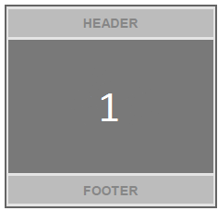

2 Column Left
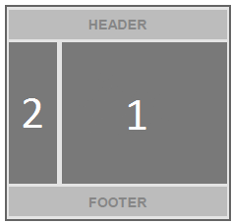

2 Column Right
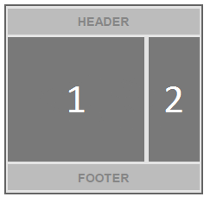

System Page Templates
The following System Page Templates will be created in the ‘Global Layout’ Publication:
- z_General_ASAX
- z_General_ASCX
- z_General_ASHX
- z_General_ASPX
- z_General_CONFIG
- z_General_CS
- z_General_CSS
- z_General_DLL
- z_General_HTC
- z_General_JS
- z_General_RSS
- z_General_SITEMAP
- z_General_SVC
- z_General_TXT
- z_General_XML
- z_General_XSL

Component Templates
The following Component Templates have been identified.

General Content
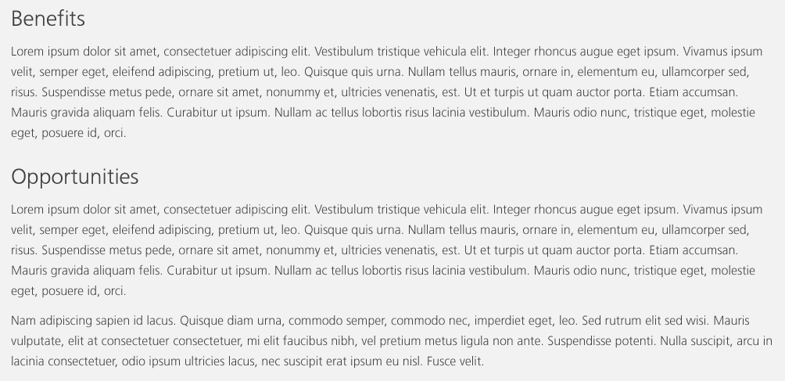
2
1
Schema | Article
Depth | 1
Notes | Links allowed in Rich Text. Title is not a link. Image is not supported  Title is H2
URL | https://projects.invisionapp.com/share/FSTNMGX3#/screens/24110486?maintainScrollPosition=false
Item Number | Description [xml_name] | Comments
1 | Title [title]
2 | Full Text [full]

Text with zoom image
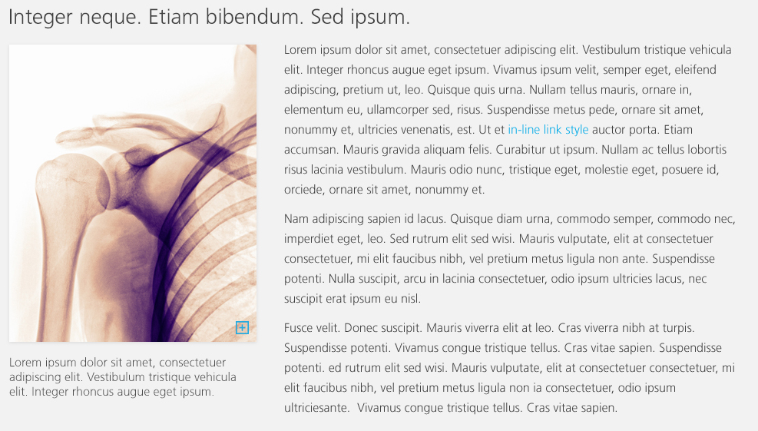
4
2
1
3
Schema | Article
Depth | 2
Notes | On click the image will be zoomed in a light box
URL | https://projects.invisionapp.com/share/FSTNMGX3#/screens/24895739?maintainScrollPosition=false
Item Number | Description [xml_name] | Comments
1 | Title [title]
2 | Thumbnail [thumbnail]
3 | Full Text [full]
4 | Summary [summary]

Image with caption
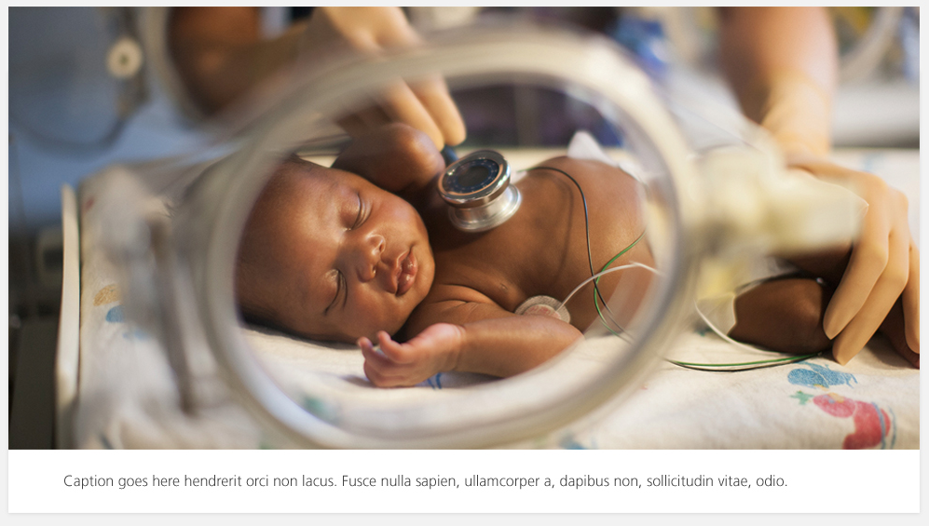
2
1
Schema | Article
Depth | 2
Notes | The caption will be shown under the image.
URL | https://projects.invisionapp.com/share/FSTNMGX3#/screens/24895739?maintainScrollPosition=false
Item Number | Description [xml_name] | Comments
1 | Banner Image [banner]
2 | Summary [summary]

Text with quote
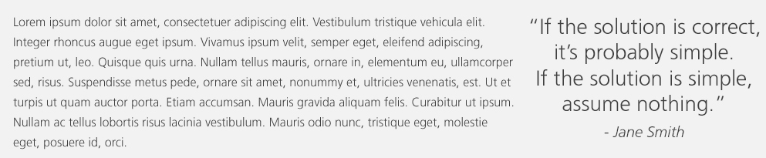
2
1
2b
2a
Schema | Article – With related content Quote
Depth | 2
Notes | The pull quote will be shown on the page as a specific quote element.
URL | https://projects.invisionapp.com/share/FSTNMGX3#/screens/24895739?maintainScrollPosition=false
Item Number | Description [xml_name] | Comments
1 | Full Text [full]
2 | Related Content [related_content][0] | First related content that is a Quote component
2a | Quote [quote]
2b | Name [name]

Secondary Navigation
1a+1b+1c
Schema | Component List – List of Links (Internal Links External Links)
Depth | 2
Notes | This is a list of links and the active page will have a specific CSS class assigned to it.
URL | https://projects.invisionapp.com/share/FSTNMGX3#/screens/24250165?maintainScrollPosition=false
Item Number | Description [xml_name] | Comments
1 | List [list] (Internal and External Link schemas)
1a | Title [title]
1b | Link [link]
1c | Target [target]

Intro Title
1
2
Schema | Article
Depth | 1
Notes | Title is H2  Image is not supported
URL | https://projects.invisionapp.com/share/FSTNMGX3#/screens/24102400?maintainScrollPosition=false
Item Number | Description [xml_name] | Comments
1 | Title [title]
2 | Full text [full]

News Title
1
2
Schema | News
Depth | 1
Notes | Title is H2
URL | https://projects.invisionapp.com/share/FSTNMGX3#/screens/24895708?maintainScrollPosition=false
Item Number | Description [xml_name] | Comments
1 | Title [title]
2 | Category [category]

Banner
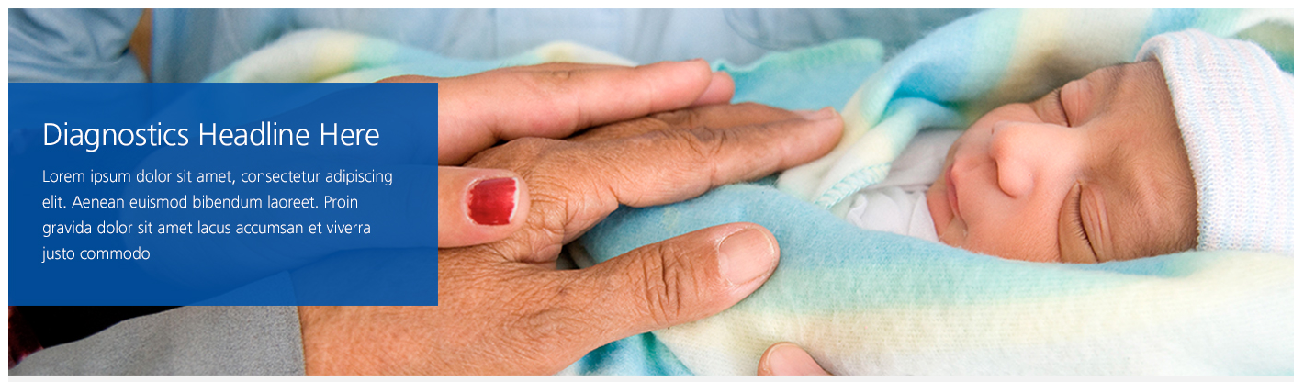
2
3
1
Schema | Banner
Depth | 2
Notes | Medium banner  Position of textbox can be controlled by the Metadata field text_alignment.  Colour and opacity of background and colour of text can be controlled by the Metadata fields on the Banner schema  Not entering title text results in no textbox.
URL | https://projects.invisionapp.com/share/FSTNMGX3#/screens/24102494?maintainScrollPosition=false
Item Number | Description [xml_name] | Comments
1. | Banner [banner]
2. | Title [title] | Optional
3. | Sub title [sub_title] | Optional
4. | Link [link] | Optional

Carousel

4
2
3
1
Schema | Component list – Banner components
Depth | 3
Notes | A Carousel is a list of banners that can be cycled through.  Position of textbox can be controlled by the Metadata field text_alignment.  Colour and opacity of background and colour of text can be controlled by the Metadata fields on the Banner schema  Not entering title text results in no textbox.
URL | https://projects.invisionapp.com/share/FSTNMGX3#/screens/24102202?maintainScrollPosition=false
Item Number | Description [xml_name] | Comments
1. | Banner [banner]
2. | Title [title] | Optional
3. | Sub title [sub_title] | Optional
4. | Link [link] | Optional

Hero

1
Schema | Image / Video
Depth | 2
Notes | Image or Video rendered out  If it is a video rendered out there will be output the rich snippet as specified in the Rich Snippets section.
URL | https://projects.invisionapp.com/share/FSTNMGX3#/screens/24110486?maintainScrollPosition=false
Item Number | Description [xml_name] | Comments
1 | Url [title]

Promo

3
2
4
1
Schema | Banner
Depth | 2
Notes | Optional Text and Link for the template
URL | https://projects.invisionapp.com/share/FSTNMGX3#/screens/24102202?maintainScrollPosition=false
Item Number | Description [xml_name] | Comments
1 | Banner [banner]
2 | Title [title]
3 | Sub Title [sub_title]
4 | Link [link]

Product Verticals List
2
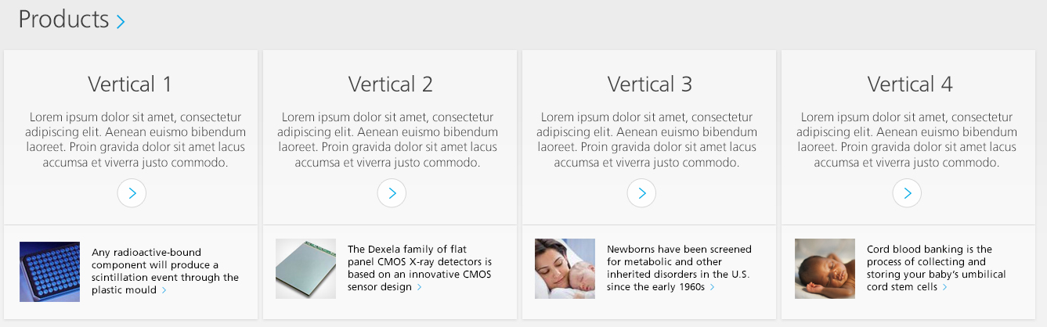
1
1cb
1ca
1c
1b + 1d
1a + 1d
Schema | Component List – Article
Depth | 4
Notes | The verticals list is contained within a component list.  Each article has a related content article component that is shown at the bottom of the vertical pod.
URL | https://projects.invisionapp.com/share/FSTNMGX3#/screens/24102202?maintainScrollPosition=false
Item Number | Description [xml_name] | Comments
1 | List
1a | Title [title]
1b | Summary Text [summary]
1c | Related Content [related_content]
1ca | Summary text [summary] | This is the content from the linked article component
1cb | Thumbnail [thumbnail]
1d | Related Links [related_links]

Leadership List
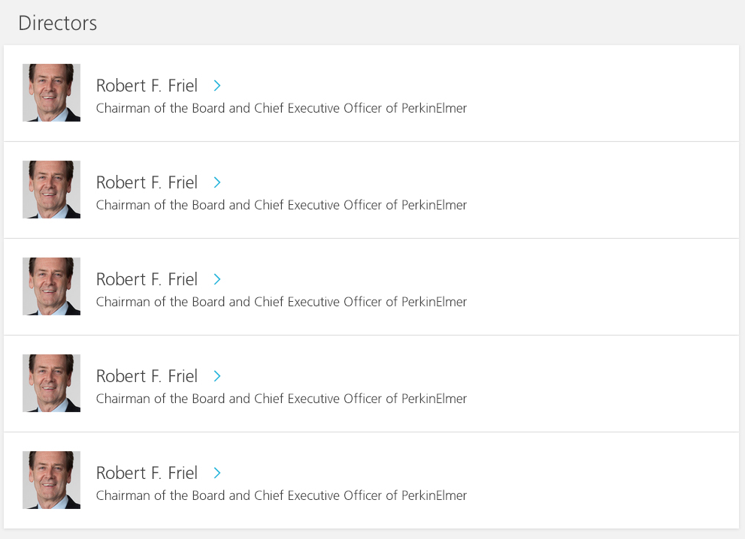
1
2
1a
1c
1b + 1d
Schema | Component List – Article Components
Depth | 3
Notes | List of Article components to be rendered as thumbnail list. This will output the rich snippet as specified in the Rich Snippets section.  Thumbnail is required  Link will be added to the title if present
URL | https://projects.invisionapp.com/share/FSTNMGX3#/screens/24102377?maintainScrollPosition=false
Item Number | Description [xml_name] | Comments
1 | List [list] (Internal and External Link schemas)
1a | Thumbnail [thumbnail]
1b | Title [title]
1c | Summary Text [summary]
1b | Related Links [related_links]
2 | Title [title]

Leadership Detail
2

3
1
Schema | Component List – Article Components
Depth | 3
Notes | The article component will be displayed as a leadership detail. This will output the rich snippet as specified in the Rich Snippets section.
URL | https://projects.invisionapp.com/share/FSTNMGX3#/screens/24102377?maintainScrollPosition=false
Item Number | Description [xml_name] | Comments
1 | Thumbnail [thumbnail]
2 | Title [title]
3 | Full Text [full]

Homepage Feature

3
2 + 4
4
1
Schema | Article
Depth | 2
Notes | The first related link is added to the title and displayed at the bottom of the link
URL | https://projects.invisionapp.com/share/FSTNMGX3#/screens/24102202?maintainScrollPosition=false
Item Number | Description [xml_name] | Comments
1 | Banner Image [banner]
2 | Title [title]
3 | Sub title [sub_title]
4 | Related Links [related_links]

Feature

3
2
1
Schema | Article
Depth | 2
Notes | The first related link is added to the title
URL | https://projects.invisionapp.com/share/FSTNMGX3#/screens/24093676?maintainScrollPosition=false
Item Number | Description [xml_name] | Comments
1 | Banner Image [banner]
2 | Title [title]
3 | Sub title [sub_title]
4 | Related Links [related_links]

Full Feature
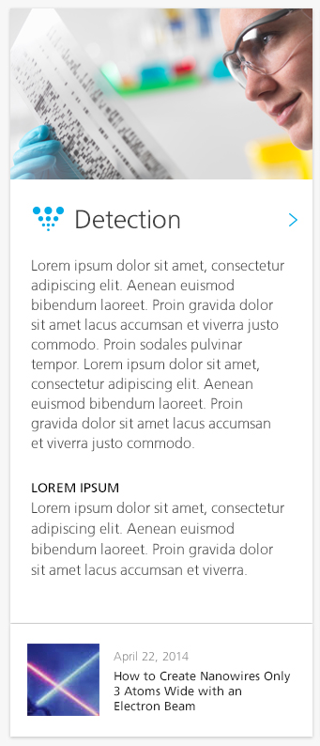
6
3
1
2 + 4 + 5
Schema | Article
Depth | 2
Notes | The related news will be dynamically rendered based on the News category metadata on the article component. The latest news article in the given category will be shown.
URL | https://projects.invisionapp.com/share/FSTNMGX3#/screens/24102400?maintainScrollPosition=false
Item Number | Description [xml_name] | Comments
1 | Banner Image [banner]
2 | Title [title]
3 | Summary text [summary]
4 | Related Links [related_links] | Only the first link is used
5 | Icon [icon] | The icon metadata will add the class for the css icon.
6 | News Category [news_category] | Dynamically retrieved latest news for the specified category.

Large Feature
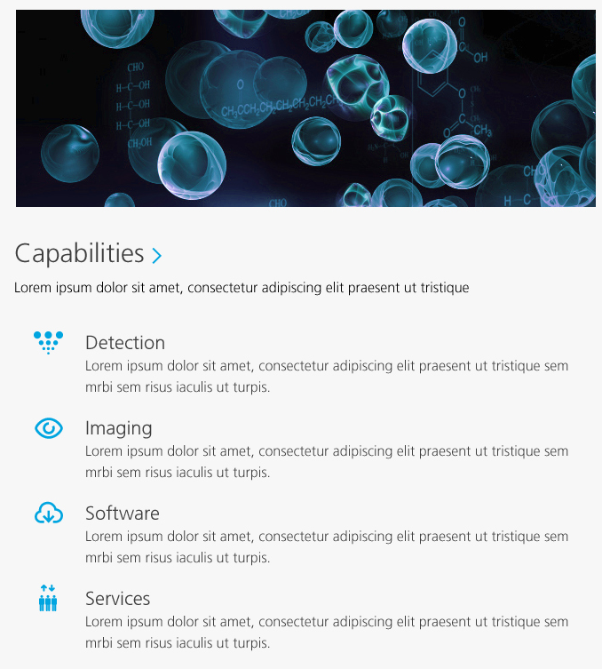
5b + 5d
5c
5a
5
3
2 + 4
1
Schema | Article
Depth | 3
Notes | Optional header image
URL | https://projects.invisionapp.com/share/FSTNMGX3#/screens/24102379?maintainScrollPosition=false  https://projects.invisionapp.com/share/FSTNMGX3#/screens/24102202?maintainScrollPosition=false
Item Number | Description [xml_name] | Comments
1 | Banner Image [banner] | Optional
2 | Title [title]
3 | Summary Text [summary]
4 | Related links [related_links] | Only the first link is used
5 | Related Content [related_content]
5a | Icon [icon] | The icon metadata will add the class for the css icon.
5b | Title [title]
5c | Summary Text [summary]
5d | Related Links [related_links] | Only the first link is used

Sitemaps
Design required from Zero degrees
Schema | Code – Empty component
Depth | 1
Notes | This template will render out a display from the sitemap XML

Newsletter signup
3
2
1
Schema | Article
Depth | 2
Notes | The thumbnail will be used as the image and the link will be the first Related link. This will go to an existing newsletter page.
URL | https://projects.invisionapp.com/share/FSTNMGX3#/screens/24895708?maintainScrollPosition=false
Item Number | Description [xml_name] | Comments
1 | Thumbnail [thumbnail]
2 | Full text [full]
3 | Related Links [related_links] | Only the first link will be used if multiple.

Social News

1a+1b
1
Schema | Component List – List of Links
Depth | 3
Notes | Each link will be displayed with the links image displayed.
URL | https://projects.invisionapp.com/share/FSTNMGX3#/screens/24895708?maintainScrollPosition=false
Item Number | Description [xml_name] | Comments
1 | List [list] (Internal and External Link schemas)
1a | Image [image]
1b | Link [link]

Side Content

1
2
Schema | Article
Depth | 2
Notes | The side content will only be displayed on the 2 column layout pages. It will be displayed in the side column
URL | https://projects.invisionapp.com/share/FSTNMGX3#/screens/24102458?maintainScrollPosition=false
Item Number | Description [xml_name] | Comments
1 | Banner Image [banner]
2 | Summary text [summary]

Side Image

3
4
2
1
Schema | Banner
Depth | 2
Notes | Colour and opacity of background and colour of text can be controlled by the Metadata fields on the Banner schema  The side image will only be displayed on the 2 column layout pages. It will be displayed in the side column
URL | https://projects.invisionapp.com/share/FSTNMGX3#/screens/24102377?maintainScrollPosition=false
Item Number | Description [xml_name] | Comments
1. | Banner [banner]
2. | Title [title] | Optional
3. | Sub title [sub_title] | Optional
4. | Link [link] | Optional

Article links

1a+1b+1c
2
1
Schema | Component List – List of Links
Depth | 2
Notes | The article links will only be displayed on the 2 column layout pages. It will be displayed in the side column
URL | https://projects.invisionapp.com/share/FSTNMGX3#/screens/24102377?maintainScrollPosition=false
Item Number | Description [xml_name] | Comments
1 | Title [title]
2 | List [list] (Internal and External Link schemas)
2a | Title [title]
2b | Link [link]
2c | Target [target]

Resource List
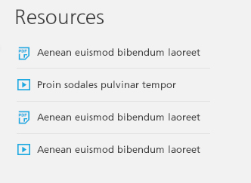
2c
2a + 2b
2
1
Schema | Component List
Depth | 3
Notes | The resource list will only be displayed on the 2 column layout pages. It will be displayed in the side column
URL | https://projects.invisionapp.com/share/FSTNMGX3#/screens/24895708?maintainScrollPosition=false
Item Number | Description [xml_name] | Comments
1 | Title [title]
2 | List [list] (Multimedia schemas)
2a | Title [title]
2b | URL , Multimedia link
2c | Type Icon | Dependant on the multimedia type

Side Navigation
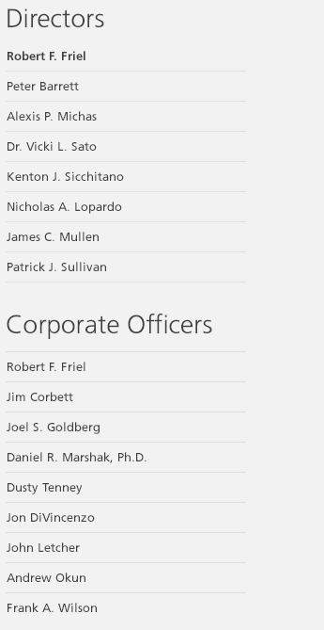
2a+2b+2c
1
2
Schema | Component List
Depth | 2
Notes | The right navigation will only be displayed on the 2 column layout pages. It will be displayed in the side column
URL | https://projects.invisionapp.com/share/FSTNMGX3#/screens/24102376?maintainScrollPosition=false
Item Number | Description [xml_name] | Comments
1 | Title [title]
2 | List [list] (Internal and External Link schemas)
2a | Title [title]
2b | Link [link]
2c | Target [target]

Share/Favourite
Currently under discussion with Gauri on position of this and removing the counts from the widgets. Also adding Google + to the supported .
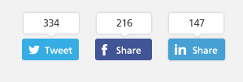
Schema | Code – Empty component
Depth | 1
Notes | The front end API for each of the sites will be used to display the counts of the share of the active page.  These are not content managed.
URL | https://projects.invisionapp.com/share/FSTNMGX3#/screens/24895708?maintainScrollPosition=false

Summary List
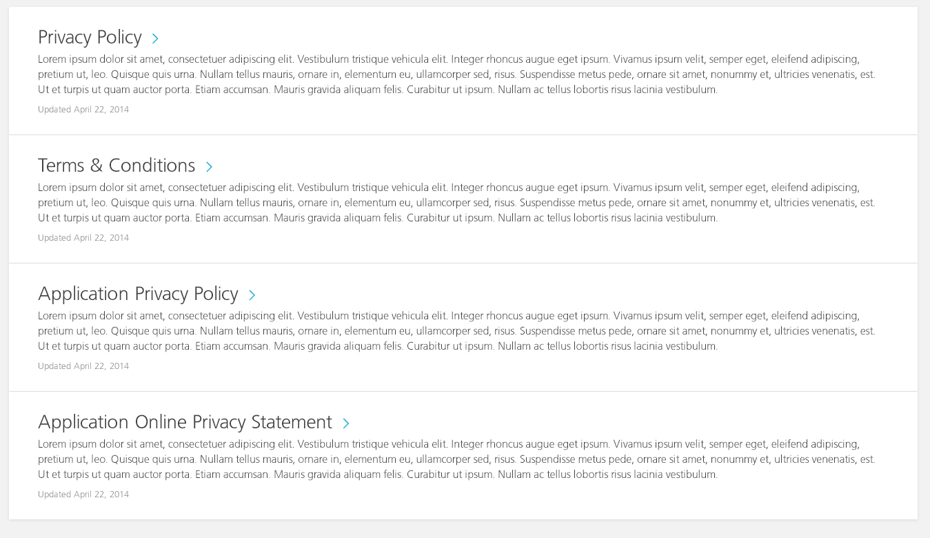
1b + 1c
1
1a
Schema | Component List – Article
Depth | 3
Notes | The summary list will display a list of articles with the summary text displayed with the title.
URL | https://projects.invisionapp.com/share/FSTNMGX3#/screens/24250165?maintainScrollPosition=false
Item Number | Description [xml_name] | Comments
1 | List [list] (Article)
1a | Summary [summary]
1b | Title [title]
1c | Link [related_link]

Logos & Images List
2
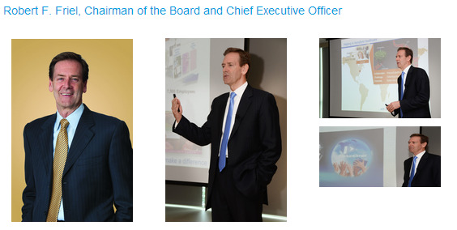
1a
1
Schema | Component List – Article
Depth | 3
Notes | The images will be able to be displayed in a lightbox with the banner image shown when you click on the thumbnail.
URL | http://perkin.zerodegreesinc.com/sprint1/prototype/#p=logos___images  http://www.perkinelmer.co.uk/ourcompany/pressroom/logos/default.xhtml
Item Number | Description [xml_name] | Comments
1 | List [list]
1a | Thumbnail [thumbnail]
1b | Title [title]
2 | Title [title]

Videos & Podcasts

1
3
2+4
Schema | Article
Depth | 2
Notes | The video and podcast component template will link off to videos and podcasts on 3rd party sites.
URL | https://projects.invisionapp.com/share/FSTNMGX3#/screens/24102458?maintainScrollPosition=false
Item Number | Description [xml_name] | Comments
1 | Thumbnail [thumbnail]
2 | Title [title]
3 | Summary text [summary]
4 | Related Link [related_link]

Dynamic Templates

Feedmagnet widget
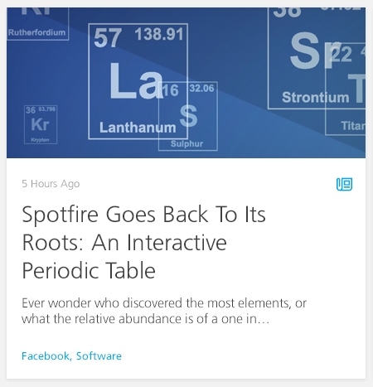
Schema | Code – Empty component
Notes | The Feedmagnet JavaScript will be called to populate the promo with content. TBC regarding layout.
URL | https://projects.invisionapp.com/share/FSTNMGX3#/screens/24102202?maintainScrollPosition=false

Dynamic News Navigation
Schema | Code – Empty component / Internal or External Link
Notes | The dynamic news navigation will post back to the page it is on with the selected category in the querystring. This is used in relation to the “Dynamic News List”  There is the option to have an additional link on the end of the navigation. This will be displayed if the template is added to the page with a link component.
URL | https://projects.invisionapp.com/share/FSTNMGX3#/screens/24102204?maintainScrollPosition=false

Featured Dynamic News
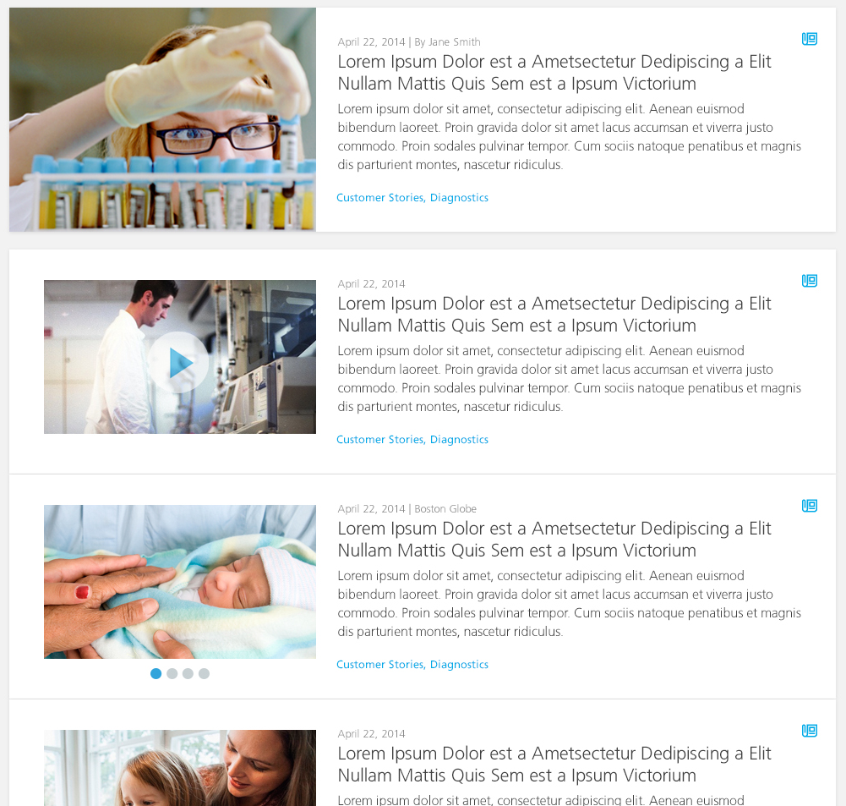
Schema | Code – Empty component
Notes | This lists the news from the broker database. This works with the Dynamic news navigation to allow the news listed to be filtered by category. This will only show the latest news article that has been tagged with the filtered category and the “featured” category.
URL | https://projects.invisionapp.com/share/FSTNMGX3#/screens/24102204?maintainScrollPosition=false

Dynamic News List
Schema | Code – Empty component
Notes | This lists the news from the broker database. This works with the Dynamic news navigation to allow the news listed to be filtered by category.
URL | https://projects.invisionapp.com/share/FSTNMGX3#/screens/24102204?maintainScrollPosition=false

Related News Dynamic List
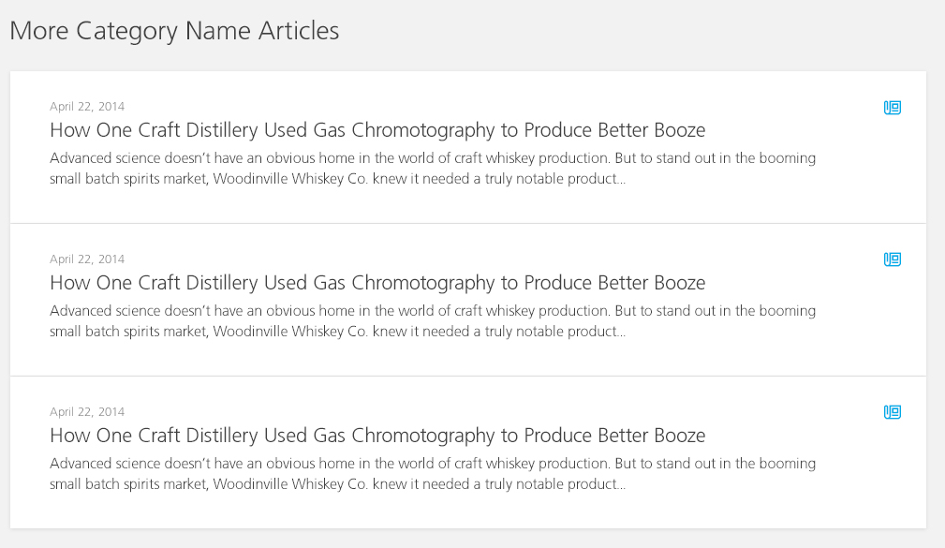
Schema | News / Code – Empty component
Notes | This is a short list of dynamic news articles based on the news categories selected in the news component metadata. This can also be used with the empty component where it will list the latest news for all categories.
URL | https://projects.invisionapp.com/share/FSTNMGX3#/screens/24895708?maintainScrollPosition=false

System Component Templates
The following System Component Templates will be created in the 02 Functionality Publication:
- Sitemap
  - Will use the Build ASP.NET Sitemap C# TBB which will examine the Structure Groups and include items which are marked to show in Sitemap.
- Corporate Navigation
  - This will generate out the top navigation will the additional fields from the metadata added to the top navigation XML.
- Application Settings
  - This will convert the items in the Publication Metadata to XML in order for the application to consume it.
- Labels
  - This will publish a DD4T XML representation of Labels.
- Country switcher XML
  - This will publish a XML representation of the Language sites category to be consumed by the site.

DD4T Templates
To have dynamic components in the broker DB there needs to be a specific template set up for each schema that is set to be dynamically published. Each template will have the DD4T component TBBs added to them.
The broker templates needed for this phase are:
- News Broker Template

ASP .Net Controls
This section outlines the .NET code that will be required to deliver key functionality. No server-side code will be deployed to the Global Assembly Cache – only stored within each sites “bin” folder.

Global Page Elements

Header
The header will be part of the _layout view so that it is included in every page. This will include the logo, main navigation, search, share icons, stock feed, login button, country selector and shopping cart.
The logo and share icons will be managed through the publication metadata that will be published to a XML document to be read in to be displayed.
PerkinElmer will implement the Shopping cart, Login and Stock ticker implementations. PerkinElmer will also be responsible for implementing the search box functionality and search of all pages and content using Endeca.

Top Navigation
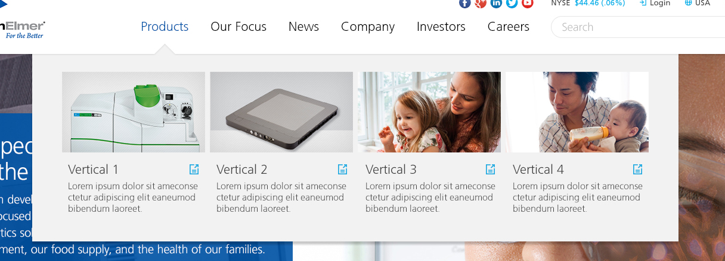


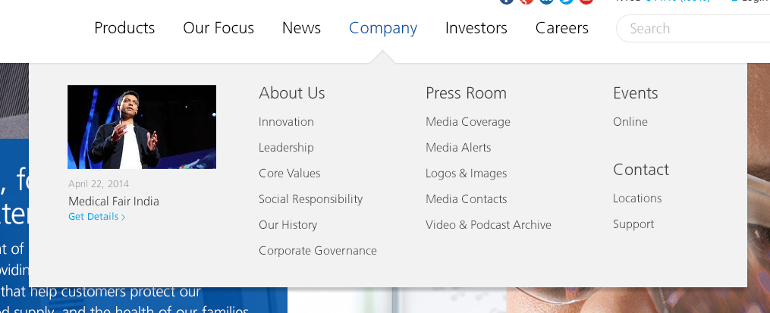


The Top navigation will be managed through a Category called Top Navigation. The keywords in this category will have the metadata schema “Top Navigation Item” assigned to them. This schema allows an image, icon, title, summary and link to be displayed.
The navigation doesn’t have a consistent design across the sections. Depending on the order number of the navigation will change the data that is displayed in the navigation from the metadata schema and also the look and feel and position (as per the designs).
The dynamic news will be loaded form the broker DB to be displayed in the top navigation. There will not be any configuration options for which news items to show.

Language Switcher
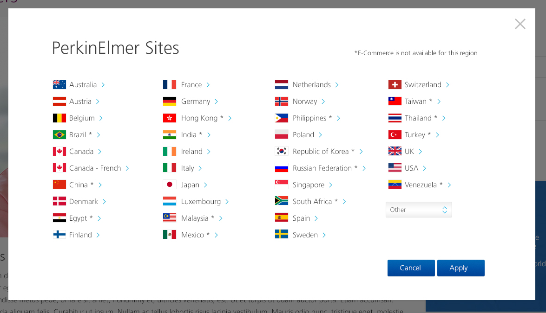
The language switcher will be included through the page layout in to the header. This will display all the country sites that are available. This list will be content managed through a category. This category will be published out as a XML file that will then be read in to display the country list.

Search

This is to be implemented by PerkinElmer directly once we handover the code to them.

Footer
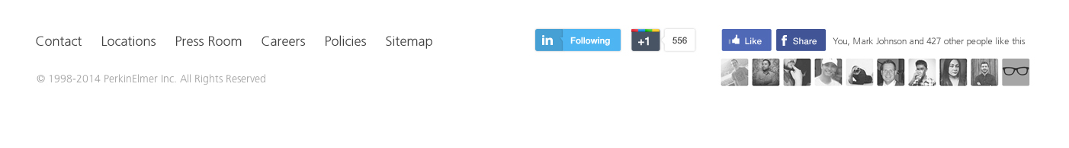
The footer will be part of the _layout view so that it is included in every page. The share and like social media buttons will be displayed through the JavaScript and will not be content managed. The API codes will be managed in the publication metadata.
The footer links will be added to the publication metadata with a list of internal or external links.
The publication metadata is published out as a XML file that will then be read in to display the footer links.

.NET Code
The following section details the solution structure for the Web Application (not Tridion). Any .NET code written will follow Building Blocks’ standards and will be unit tested if sufficiently complex.
Please note classes and new projects not listed below may be deemed to be required during development so the below is not final.

.Net Classes

News Service
There needs to be a news service to retrieve news items from the broker data base. This service will expose the following methods
- LatestNews()
  - Retrieve the latest news from the broker database for all categories
- GetNewsByCategory(string category,)
  - Get the latest news for a given category
- GetNewsByCategory(List<string> category)
  - Get the latest news for a given list of categories.
- GetNewsCategories()
  - Return the list of active news categories

Solution Architecture
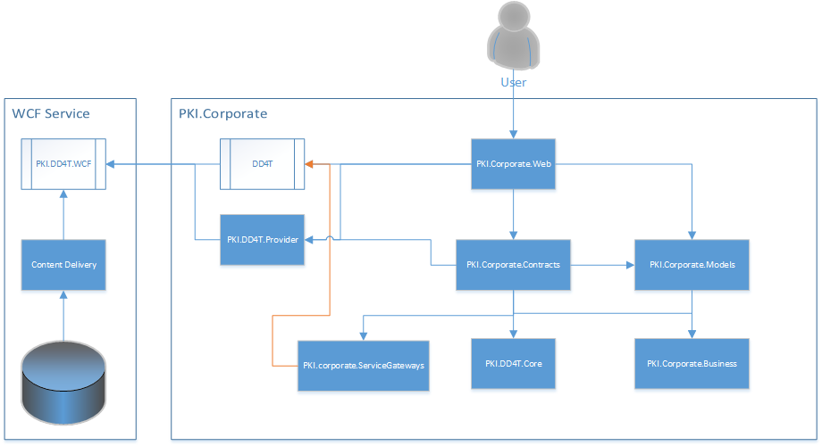

Website Code Architecture
We will create one Visual Studio Project within the new PKI. Corporate solution:
- PKI.Corporate.Web
  - This will contain the Web Application – Controllers, Views and HTML Helpers, configuration, routing and any project specific items.
- PKI.Corporate.Models
  - This project will contain all domain models for the solution.
- PKI.Corporate.Contracts
  - This project contains all the interfaces for the solution.
- PKI.Corporate.Business
  - This project will contain all business logic and communicate between the Service Gateways and the Web Application.
- PKI.DD4T.Core
  - This will contain generic DD4T helpers and infrastructure classes which could be reused for any project.
- PKI.Corporate.ServiceGateways
  - This project will contain the code to connect to the Tridion broker services and return the dynamic templates.
- PKI.DD4T.TridionProvider
  - This project connects thought the PKI Tridion WCF service provided by PerkinElmer. This implements the DD4T content provider interfaces.
- PKI.Corporate.Tests
  - This project will contain any unit tests for the solution. These will be executed when a build is run through TeamCity. We may also create AA tests and integration tests here.

C# Template Building Blocks Code
The C# Template Building Blocks Solution will be called PKI.TridionTemplates and contain a single project called PKI.TridionTemplates.
This solution has been created for the Microsites project. These TBBs will be reused through the 02 Functionality Publication in Tridion.

PKI Tridion WCF Service
This is a WCF service provided by PKI which acts as a service layer to the Tridion Broker APIs, this avoids the need for the Corporate site to include direct references to the Tridion Content Delivery dlls. It also provides a central point of interaction with Tridion Content. The Corporate Site accesses this via the PKI.DD4T.TridionProvider.

Additional Libraries
On top of the standard Tridion Content Delivery DLLs, the front-end website will also make use of the following .NET libraries:
- Log4net
- BuildingBlocks.Core
- BuildingBlocks.DD4T.MarkupModels
- Unity
- DD4TFramework
- DD4T.Mvc
- DD4T.Providers.Tridion2011Sp1

Integrations and Services
This section of the document outlines the web services and third party integrations that will be used by the new website to serve up the desired content.

Third Party Integrations
Throughout the website there are a number of integrations with third party applications. The details of each of these are given below.

Feedmagnet
Website: http://www.feedmagnet.com/
Feedmagnet will be used to display editorially controlled social media content in the Feedamgnet widget.

Facebook
Website: https://developers.facebook.com/?ref=pf
The Facebook API will be integrated to show the shares of a page through there site.

Twitter
Website: https://dev.twitter.com/
The Twitter API will be integrated to show the shares of a page through there site.

Linked In
Website: http://developer.linkedin.com/
The Linked in API will be integrated to show the shares of a page through there site.
Google plus?

Tracking
Google Tag Manager will be used to add all Tracking scripts. Standard Google Analytics will be configured with the account stored on Publication Metadata. This section details other types of tracking that may be required and how these will be added.

Event Tracking
Event tracking will be configured using the automatic method to avoid having to add code for each Microsite and allow PerkinElmer to define their own requirements fluidly in future without the need for deployments.
- https://support.google.com/tagmanager/answer/3420054?hl=en-GB

Adobe Analytics script
Adobe Analytics will be added as detailed here: http://coderesponsible.com/how-to-add-omniture-to-google-tag-manager/
PerkinElmer will provide the Adobe Analytics s_code.js file(s) which will be added to the Layout file directly.

Rich Snippets
Building Blocks will follow Google’s recommendation to use Microdata. This involves adding attributes to existing elements to describe a type of data. For more details see here: https://support.google.com/webmasters/answer/176035?hl=en
The Rich snippets will be implemented on the following templates:
- Leadership List
- Leadership Detail
- Hero

Person
For the leadership templates the rich snippets will be in the “People” format.
https://support.google.com/webmasters/answer/146646
The micro data fields that we will output for a person will be:
- Name
- Photo

Video
If the Hero is rendering out a video the rich snippet will be in the schema.org mark-up for videos.
https://support.google.com/webmasters/answer/2413309?hl=en&ref_topic=4603851
The micro data fields that we will output for a video will be:
- Name
- Description
- ThumbnailUrl
- Duration
- ContentUrl
- EmbedUrl
- UploadDate
The breadcrumbs will be marked up with the micro data property to identify that it is the breadcrumb.
http://schema.org/WebPage

Client Side Technologies
The following details the client-side technologies used for the project. A number of these (grunt, handlebars, assemble) are only used for creating the HTML demo prototypes used for testing the HTML and JavaScript in isolation from Tridion.

HTML5
HTML5 is the de facto standard for mark up. HTML5 tags will be used to give the page semantic meaning.

jQuery
Website: http://www.jquery.com
jQuery is a fast, small, and feature-rich JavaScript library. It makes things like HTML document traversal and manipulation, event handling, animation, and Ajax much simpler with an easy-to-use API that works across a multitude of browsers.

jQuery Unobtrusive Validation
Website: https://www.nuget.org/packages/Microsoft.jQuery.Unobtrusive.Validation/3.1.2
A library for using HTML5 Data Attributes to provide front end validation. Since the ASCX controls for forms will not need server side validation as this is provided by Pardot.

HandleBars
Website: http://handlebarsjs.com/
HandleBars is a front end Templating framework. It is not present in the final website but is used to speed up front end development.

Grunt.js
Website: http://gruntjs.com/
Grunt JS is a JavaScript build system that runs on Node.js

Assemble
Website: https://github.com/assemble/assemble
Assemble is a plugin which can compile Handlebars and other data into flat HTML.

Fonts
Website: http://www.fonts.com/font/linotype/frutiger
The frutiger font used for the site will be embed from fonts.com using the domain fast.fonts.net which has improved caching and font compression techniques.

Technical Assumptions
The following list includes all of major technical assumptions that have been made:
- Navigation will be bases on the order of the elements to define the style. If a section is removed or a new section added then the navigation will need to be reworked so that they styling is as designed for that menu.
- News content will be added through Tridion CMS not through a custom tool.
- The new corporate site will be set up within IIS as a virtual application under the main PKI.com site.
- Search will be implemented by PerkinElmer
- PKI are aware that changes to styles must be made in the HTML/LESS prototype and compiled into CSS which must then be deployed to the DD4T application.
- PKI are aware that there is no content manager support for changing fonts. All microsites will use the frutiger font.
- Unity will be used as the Dependency Injection framework.
- Caching will be configured in the web.config for items such as Labels and Navigation. PerkinElmer are aware that some items may need to wait for the cache to be visible
- Google Tag Manager will be used to add all Tracking code.
- The Countries list will be published from Tridion. PerkinElmer will be responsible for entering these into Tridion.
- We are testing and delivering a single language English site. But the site can be localised but this will not be tested in this work.
- Video support - Kaltura and YouTube only
- There is currently an upgrade to Tridion 2013 SP1 in progress by the PKI team, it is our understanding that this will not affect the build. If there are any issues caused by the upgrade then a CR may need to be raised.
- It is understood that the following sections of the PKI Corporate site will be hosted within 3rd Party sites/systems. In summary these are:
  - Press Room - Press releases, media coverage, media alerts
  - Careers/Jobs – All links, search and any sub pages within this section
  - Investors Section – All sub pages within this section (financial information, presentations, stock information, investor events)
- PKI will be responsible for managing the synchronisation of all header/footer/secondary nav links within the 3rd Party systems. These will likely become out of sync when content editors update the links in the PKI corporate site from Tridion.
- PKI will be responsible for managing the implementation of the header/footer/secondary nav etc within the 3rd Party systems.
- If Videos are hosted on YouTube (which they may be) the YouTube link will be ranked higher than the PKI page
- The development and maintenance of the PKI Tridion WCF Service is the responsibility of PKI.
- Any defects raised with the PKI Tridion WCF Service during Development Test, UAT or Warranty periods of the project will be resolved by PKI.
- Consideration may need to be given to switching back to the default provider If any issues arise from using the PKI Tridion WCF Service that may impact the delivery date or budget of the project. Alternatively a CR may need to be raised to cover any additional effort required.

Development Principles

Error handling
Log4Net will be included in the solution for logging purposes as is standard practice for Building Blocks software.
Log4Net will write to a rolling log file on the web server it resides on. In the case of the live website Log4Net will also send an email to a designated address list for ‘FATAL’ and ‘ERROR’ logging statements.
Exceptions will be handled at the highest level in the application stack and an appropriate error message displayed to the user. All business layer code will utilise try, catch and finally blocks to ensure that exceptions are caught and the dispose pattern is adhered to for IDisposable objects.
Errors will be handled by redirecting website users to a helpful .NET Custom Error Page, indicating the cause of the error (in a user friendly manner) and providing them with a link back to their previous page. The custom error page should also contain links to areas of the site that will help the user to get the information that they require – for example, a link to the search page and the FAQ page. The content of the Custom Error Page will be managed through Tridion, and will be managed by the PerkinElmer web team.
It is imperative that the error handling and logging strategy is well known within the team so that errors are handled consistently across all system components. The table below details how and why each type of error is handled.

Caching
The standard ASP.NET MVC caching techniques will be used where appropriate on the site to improve performance and scalability.
Along with this, it is also recommended that Tridion Output Caching is enabled to ensure the fast delivery of Broker stored content.

Naming Conventions
Code should be completed in accordance with the Building Blocks coding guidelines. These are outlined in Appendix A.

Testing
A separate test plan will be produced, outlining the testing that is to be performed in the following areas:
- Functional
- Scalability
- Accessibilit

Deployment and Rollback
As described earlier, there are two main facets to the code:
- The web application source code, and
- The managed code and content within Tridion.
This section of this document outlines the deployment and rollback procedures in each environment for this project.

Deployment
For the two Building Blocks environments (Development and Test) the web application source code will be managed within GIT and all deployments of this code will be controlled using TeamCity. Along with the deployment task, TeamCity will also compile, assimilate and run test against of the web application code.
Deployment of the application code from the Building Blocks Test environment to the PerkinElmer QA environment (and from the PerkinElmer QA to Production environment) will be done manually using copy and paste. It is highly recommended that a script is written for this to ensure that nothing is missed from the deployment and that all deployments are correctly versioned and managed.
The deployment of the Tridion system items (Page Templates, Component Templates, Schemas, TBBs, etc.) between environments will be done using SDL Tridion Content Porter. All Content Porter packages, and details of the deployment, should be fully documented and managed using normal release management principles. We will also save the Content Porter Configuration XML file when doing imports so we can identify exactly what has been deployed from within a Content Porter Package. After doing an import using Content Porter we should also take a copy of the Undo Package from the Content Management server (in the %TRIDION_HOME%\Content Porter\UndoPackages folder) and store this alongside the Content Porter package, configuration XML file and deployment notes.

Rollback
As can be seen from the BluePrint diagram, the new website’s Schema, Design, Content and Website Publications will be created in a separate branch within the Tridion BluePrint.
If any deployed code needs to be rolled back then GIT will contain the release versions of all versioned web application code. As mentioned above the Tridion Content Porter Undo packages should be retained and added in to the GIT release to allow a Content Port rollback.

Appendix A - Code Casing Conventions
This section of the document outlines the Building Blocks standards for casing conventions for use within all code, markup and style.

C#
Following the Microsoft standards, casing should be applied in C# as follows:
Identifier | Case | Example
Class | Pascal | AppDomain
Enum type | Pascal | ErrorLevel
Enum values | Pascal | FatalError
Event | Pascal | ValueChange
Exception class | Pascal | WebException  Note Always ends with the suffix Exception.
Read-only Static field | Uppercase | REDVALUE
Interface | Pascal | IDisposable  Note Always begins with the prefix I.
Method | Pascal | ToString
Namespace | Pascal | System.Drawing
Parameter | Camel | typeName
Property | Pascal | BackColor
Protected instance field | Camel | redValue  Note Rarely used. A property is preferable to using a protected instance field.
Public instance field | Pascal | RedValue  Note Rarely used. A property is preferable to using a public instance field.
Private member field | Camel, prefixed underscore | _redValue  Note Based on .NET Framework implementation. _ makes it easy to distinguish private members from public properties, although it is not CLR compliant.

W: www.building-blocks.com
E: info@building-blocks.com
Manchester, UK
1 Portland Street
Manchester
M1 3BE
T: +44 (0) 161 441 0600
F: +44 (0) 870 928 9739
San Francisco, CA
505 Montgomery St
Suite #1020
San Francisco, CA 94111
T: +1 (727) 608 4295
F: +1 (727) 538 4237

Copyright
All intellectual property rights including copyright subsisting in or arising from this work are owned or controlled by Building Blocks.

Confidentiality
This work and any information contained herein is submitted for the purpose of fulfilling the proposal/ contract referenced herein. It is to be treated as confidential and shall not be used for any other purpose. The work shall not be copied or disclosed to third parties in whole or in part without the prior written consent of Building Blocks.

